## **Question:“ ”**

**Story Telling: “ ”**

## **Expected Findings**

## 0.What’s the Gender Earnings Ratio Gap and unemployment rate gap

eg.Show the gender gap between different continent+worldwide

Show the slow improvement in female relative earnings and the origins of “wage discrimination”

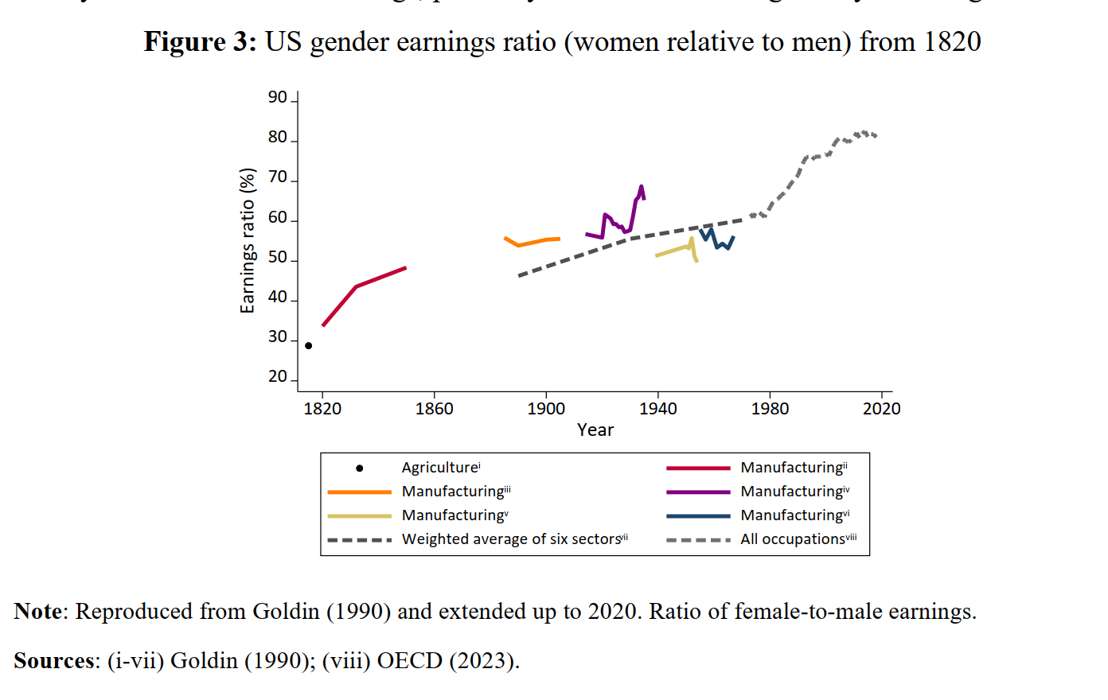

## 1. How does women’s labor participation rate change over time?

U-shaped female labor market participation over time and development

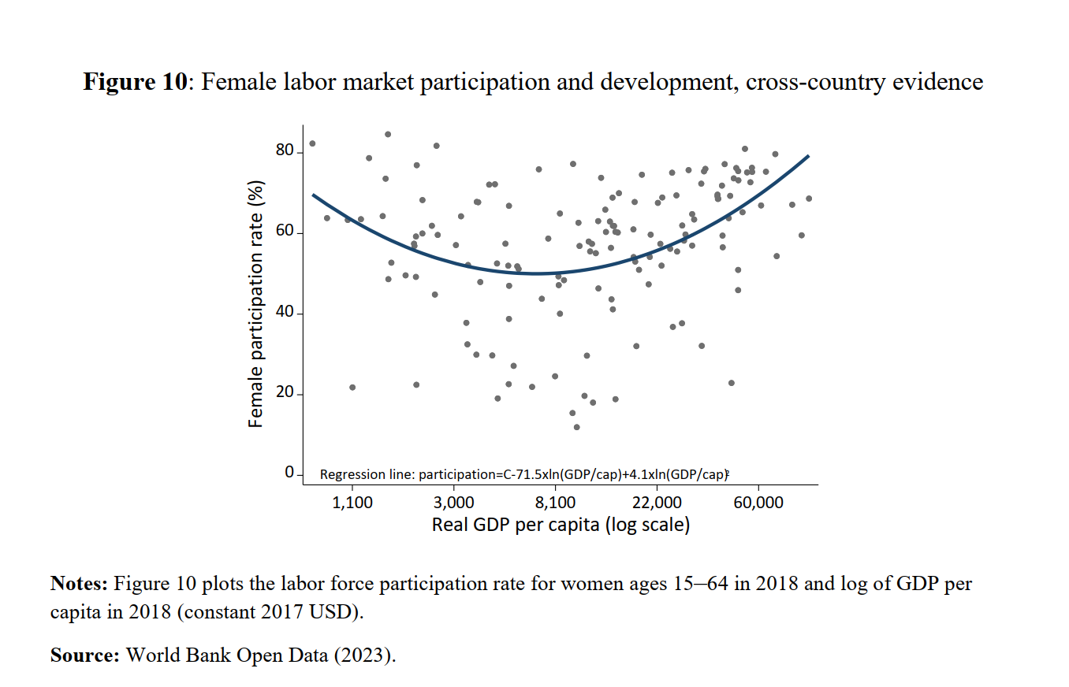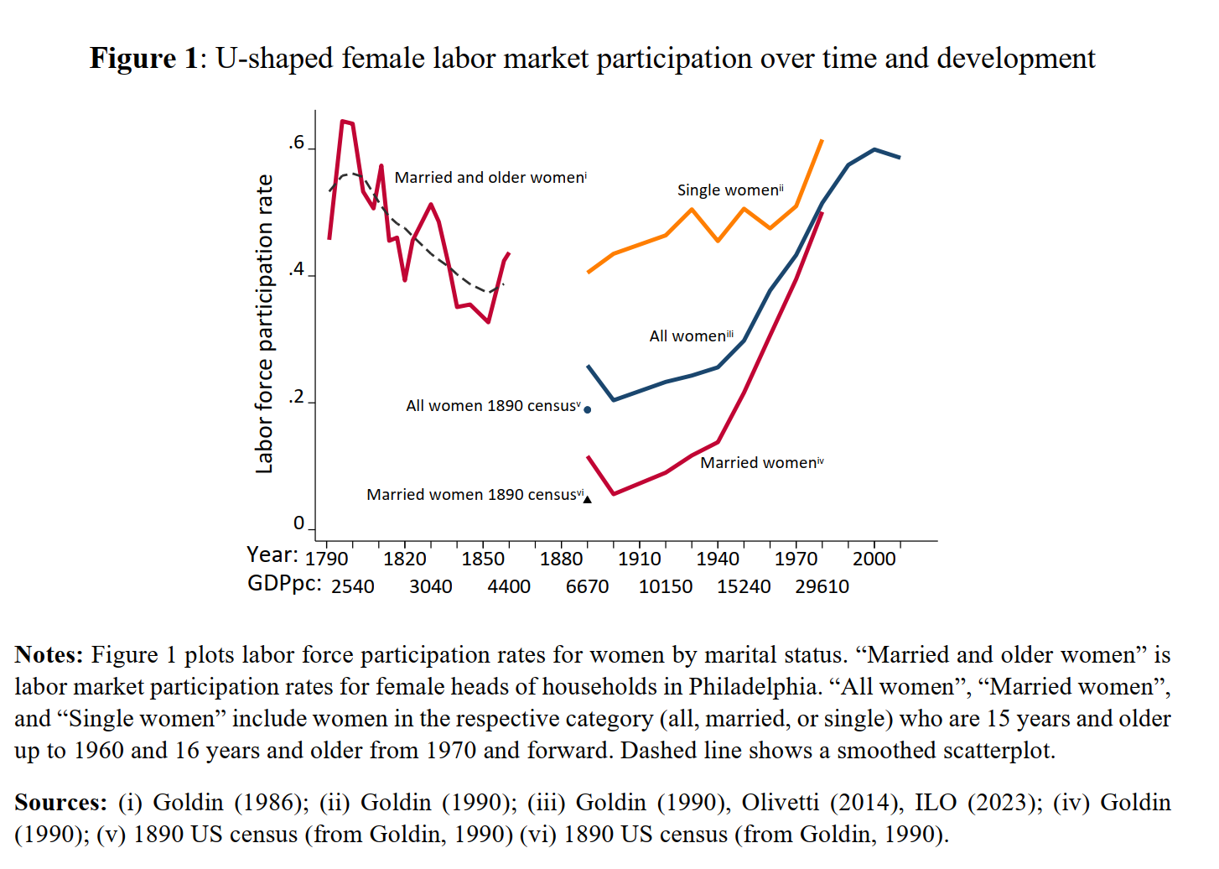

2. What is the correlation between GDP and women’s labor participation?

Similar U-Shaped GDP development. Compared to women 's unemployment rate.

Extend the findings to worldwide range to see whether it still stands.

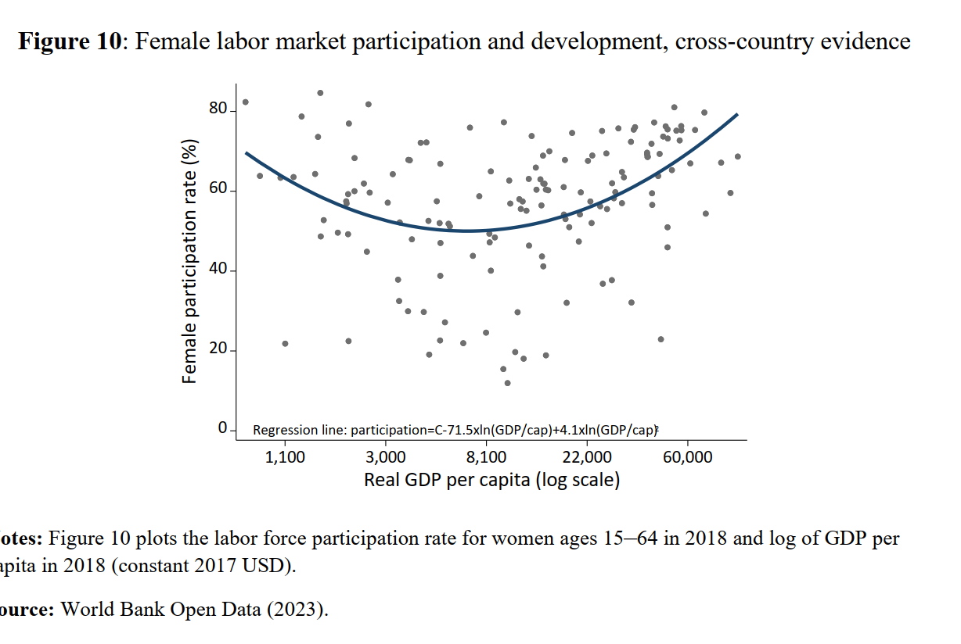

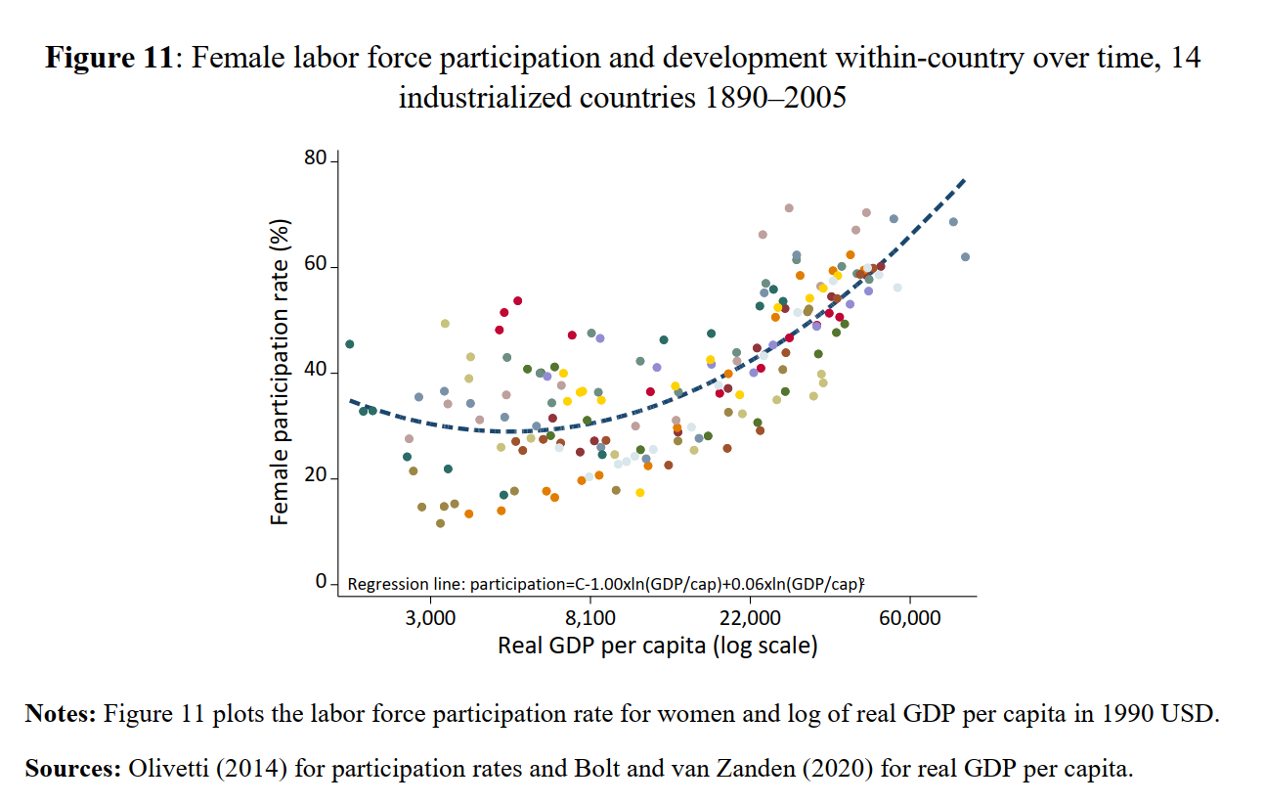

* We might see a U-shaped association. Due to their need for additional income, women may have higher labor force participation rates in less developed economies. Women's involvement rates may decline as economies develop because of increased access to education and other opportunities. Women's labor force involvement may, however, increase once more as economies achieve higher levels of development, frequently in occupations requiring greater ability and professionalism.

3.What's the connection between educational attainment and the employment rate?

Compare school rate to employment rate

Shows high education level doesn’t relate to significant decreasing employment rate gap

n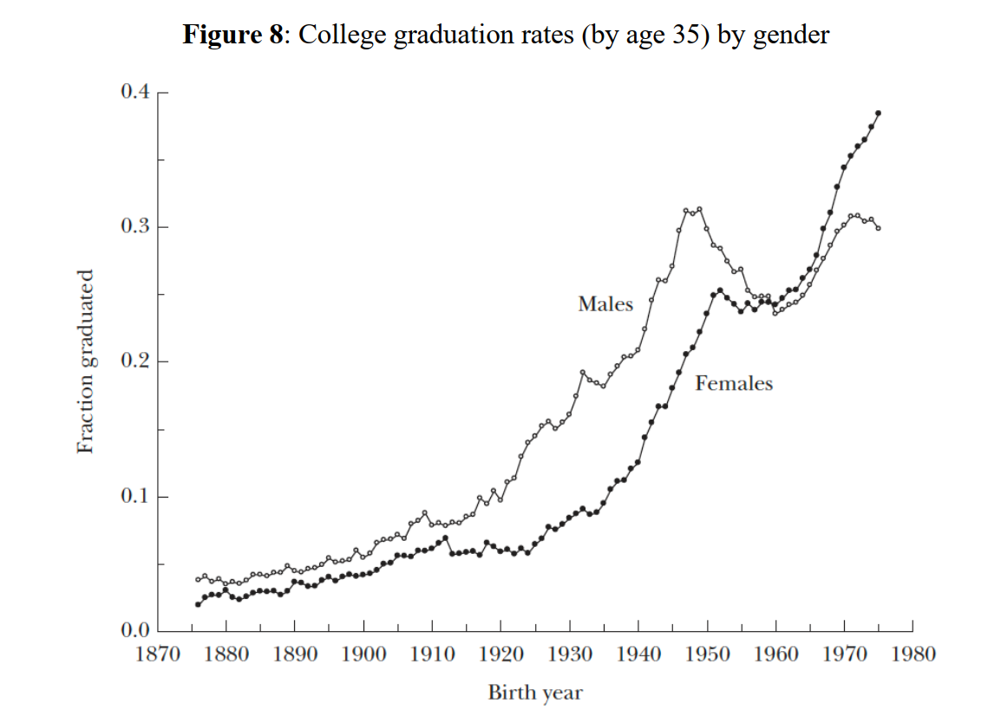o

* + 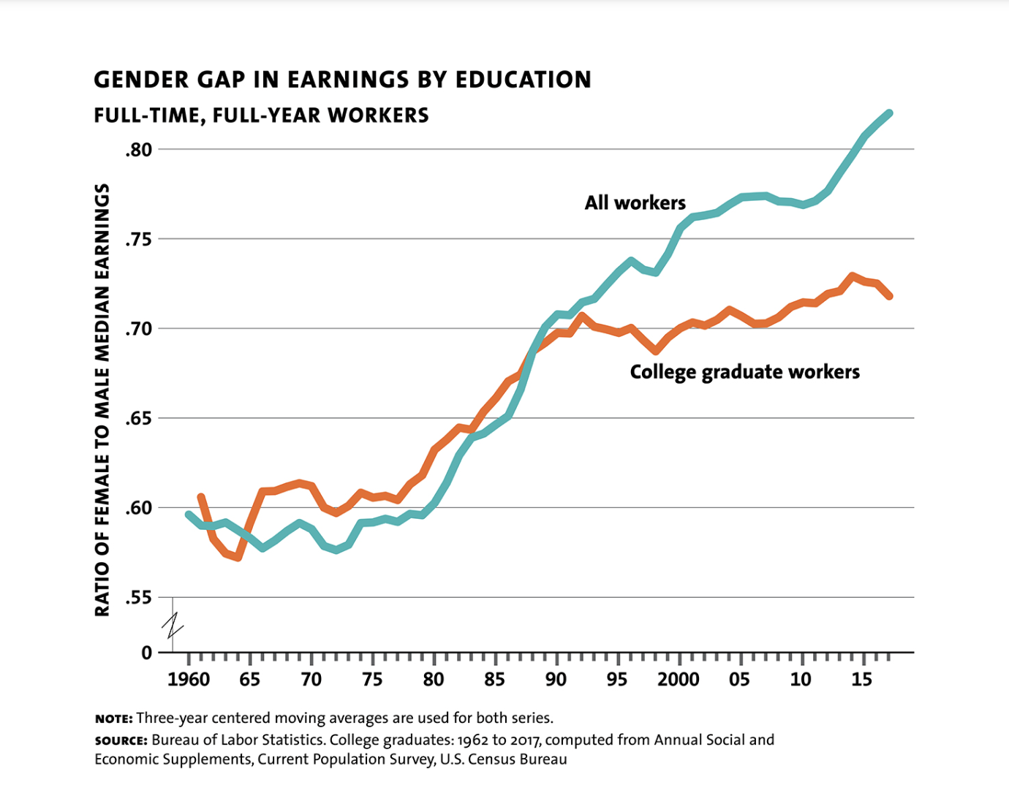
* The findings might reveal that, in recent years, women's educational levels have been steadily increasing, but disparities in employment and earnings persist, both at lower and higher education levels. The data may indicate that the extent of these disparities hasn't changed as much as anticipated.

4.What’s the connection between parenthood effect and women’s unemployment rate?

Are birth rates correlated to unemployment rate (by education level)?

* + 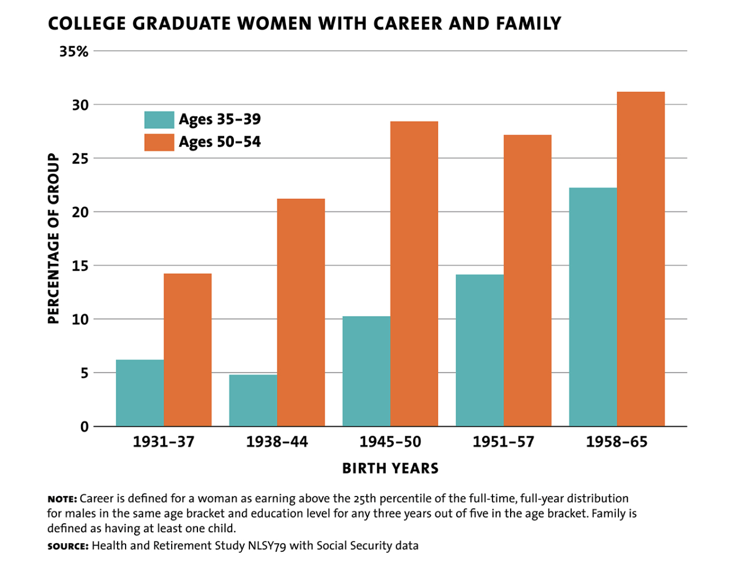
* Higher education levels (such as bachelor's degrees or advanced degrees) can result in a negative association between birth rates and unemployment rates. This may indicate that people with higher levels of education tend to put off starting a family when the economy is uncertain and may give priority to their careers or their financial security.

How do paternity and maternity leave policies in the United States differ?

* Discrepancies in perceptions and practices of maternity and paternity leave can worsen the gender pay gap. Advocating for equal paternity leave can challenge traditional norms, encourage shared parental responsibilities, and contribute to narrowing this gap.

<https://blogs.worldbank.org/opendata/investing-girls-education-time-covid-19>